1. **Find the number of accidents in each state where the accident side is “R”, and the Amenity is labeled as “FALSE”. Group By the Weather_Condition.**

**Result:**

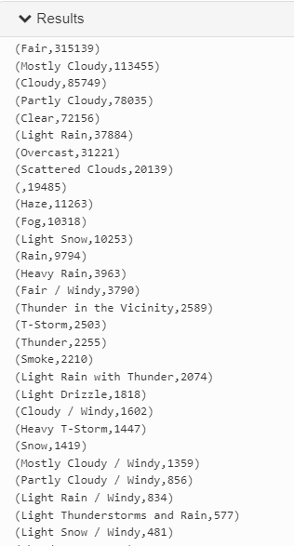 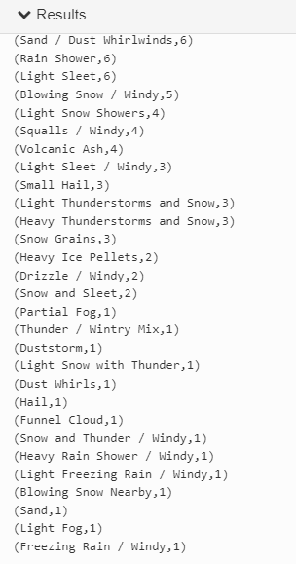

**Insight:**

We can see from this result that most accidents on the right side without the means of amenity occur when the weather is fair. In other words, the accident may not have been caused primarily by the weather in general.

This can be linked with Saudi Arabia, where the weather is fair on most days of the year, yet the accident rate is high.

1. **How many accidents occurred during the sunset when the humidity percentage was between 85 and 100?**

**Result:**

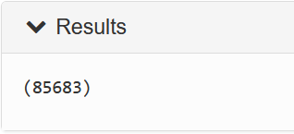

**Insight:**

The total number of accidents that occurred at night with humidity between 85 and 100 is 85683. This is less than a quarter of the data but still a big number.

Regions near the sea in Saudi Arabia suffer from a high percentage of humidity that hinders vision and can result in accidents.

1. **What is the average wind speed for accidents in each county when the wind is blowing from the west and the temperature is 25 degrees or lower?**

**Result:**

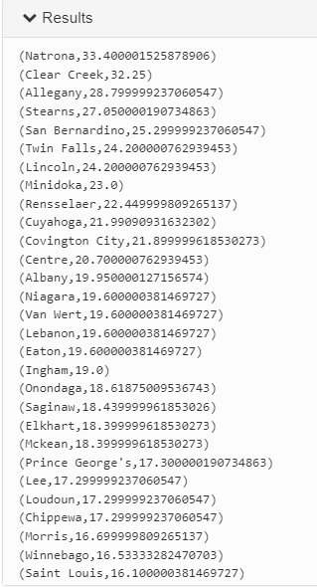

**Insight:**

According to this result, the top three counties with the highest average wind speed are Natrona, Clear Greek, and Allegany. As the west wind blows and the temperature is 25 degrees or below.

It might be related to the low temperatures and moving winds in some parts of southern and northern Saudi Arabia. Besides the heights and mountains, accidents may also occur there.

1. **Find the minimum and maximum temperatures when accidents occurred in the following states: TX, GA, AL, and FL. Group by the state.**

**Result:**

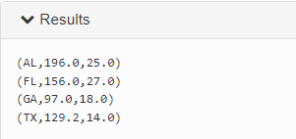

**Insight:**

The result shows maximum and minimum temperatures only for four states. Among the four states, Alabama has the highest temperature of 196 °F and Texas has the lowest temperature of 14 °F.

Among the ten hottest US states, these four were selected to demonstrate a relationship with Saudi Arabia. That is due to the fact that Saudi Arabia has a number of hot cities like Makkah, Dammam, and Al-Hasa.

1. **How many accidents with a distance of the car drifting to a stop of more than 3 miles and with the highest severity of 4?**

**Result:**



**Insight:**

From this result we can see that there are 5188 accidents that have a distance of more than 3 miles and have the highest severity so that might correlate with the distance being quite large.

Saudi Arabia is large in terms of area and most of the transportation is by car, which makes the number of drivers greater and the possibility of accidents higher.

1. **How many accidents happened that had a distance of the car drifting to a stop of or more than 0.5 miles and with a severity of 2 or more? Split the results for each accident side and save each of them in a separate dataset.**

**Result:**



**Insight:**

From this result, we can see that there are more accidents that happen with the right side of the street rather than the left side. In Saudi Arabia the driving laws for vehicles are similar as both drivers drive on the left side of the vehicle so it's more likely that accidents happen on the side that is furthest than the driver.

1. **What is the average distance for accidents for each side?**

**Result:**



**Insight:**

From this result we can see that accidents that occur on the right side are way higher in distance than those that happen on the left side . So they are way more dangerous as they are from the furthest side of the driver.

1. **Show accidents that occurred with their severity, month and year that have the weather condition as 'Sand' or 'Sand / Dust Whirlwinds' or 'Sand / Windy' in ascending order**

**Result:**

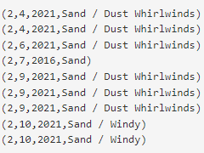

**Insight:**

From this result we can see that accidents involving Sand have the severity of 2. And a lot of those accidents have the weather type as Sand / Dust whirlwinds which are common weather types in Saudi Arabia .

1. **Find the total number of accidents by month of 2019, 2020, 2021. For the highest populated US states,which are California CA, Texas TX, Florida FL, New York NY, and Pennsylvania PA. Then compare the results with the rate of accidents in the highest populated KSA regions.**

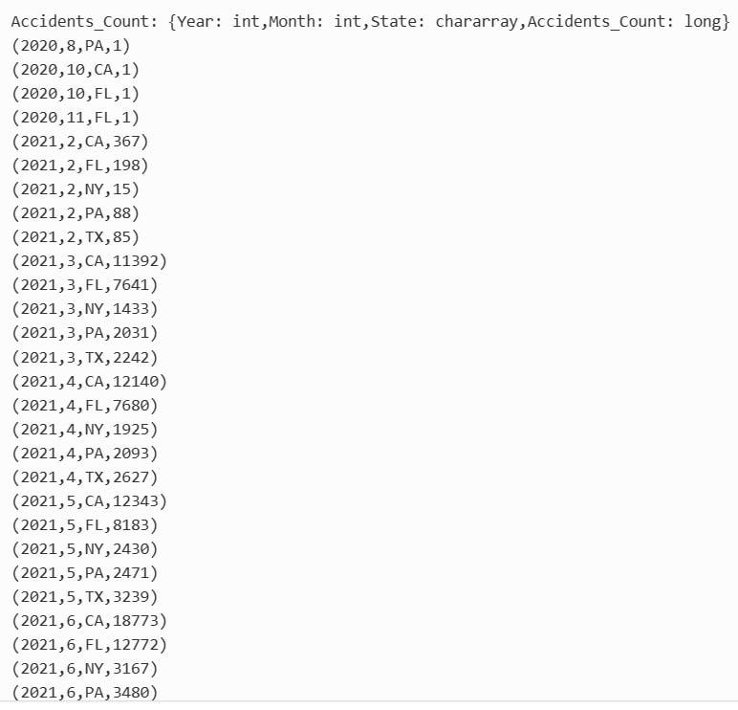

**Insight**: The results show that California, which is the highest populated State, has the highest count of accidents in all months, especially in December probably for Christmas and new year celebrations with family. The overall count results indicate the higher the population, the higher the probability of accidents. If we compare this result with Saudi Arabia, we will find similar situations. For 2020, the total population in Makkah was 9.26 million persons which account for 26.45% of Saudi Arabia's total population. As a result, it is considered the top region in population. The others are Riyadh, Eastern Region, Aseer, and Al Madinah account for 80.10% of the total population.During holidays and the months of Hajj and Ramadan, the possibility of traffic accidents increases. Here is the illustration from the Saudi General Authority for statistics about traffic accidents site by Region:

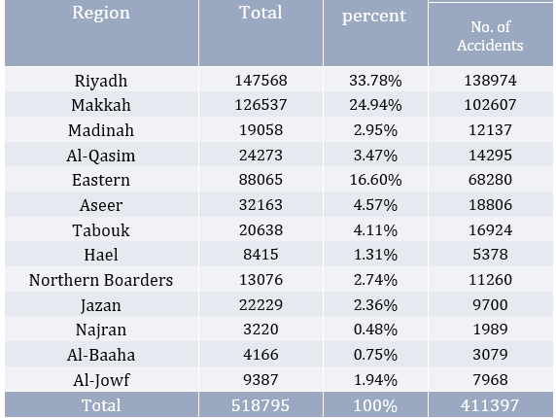

1. **The highest temperature recorded in KSA was between 45(113) C(F) - 53(127) C(F) degrees. Count the number of accidents when the temperature is in the range between 100 to 127 degrees Fahrenheit, and when the traffic calm is ‘FALSE’.Then, conclude if there is a relation between the temperature and the Increased probability of accidents.**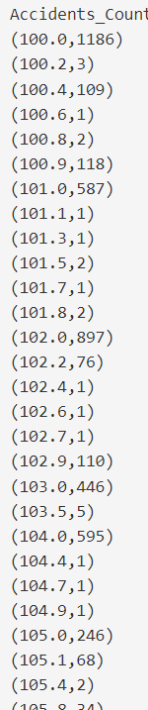

**Insight:**

The result shows that most of the accidents occur during temperatures from 37(100) - 44(111.4) C(F)degrees Fahrenheit. This temperature range is in most areas where traffic accidents occur. With the exception of the mountain highlands in the southwest of the Kingdom, which witness moderate temperatures, summer marks the beginning of a rise in temperatures in most regions to about 45(113 F) degrees. As shown in the table below:

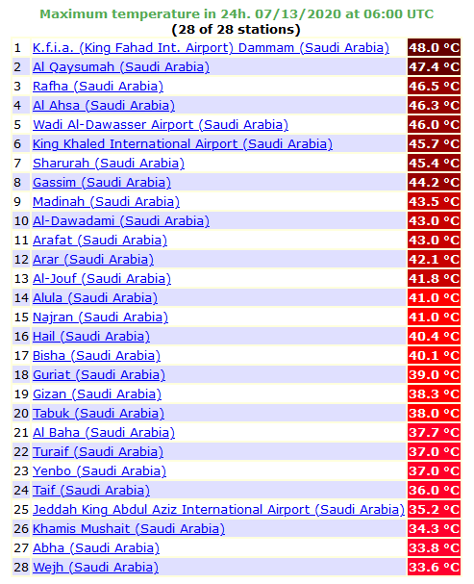

1. **The sand cover in the Kingdom of Saudi Arabia constitutes 34% of the total area of the Kingdom, which increases the activity and speed of sandstorms. Wind speed varies during sandstorms in Saudi Arabia, and increases to range between 54-63 km/h and low humidity(%). For each severity level, find how many accidents happened when the wind speed(mph) is 20 or above and humidity is less than 30%.**

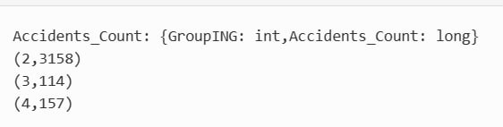

**Insight:** The query result shows the majority of accidents recorded when speed(mph) is 20 or above and humidity is less than 30% are in the 2nd severity level. I think it is imbalanced data as we have more records for severity level 2, and fewer for 3 and 4. Because the dust wave obscures the level of vision, and in turn causes obstruction of road traffic as well.

1. **Find the total number of accidents in these cities Cleveland, Westerville, Fairdale, Youngstown and Lake Forest when the weather is Fog , Fog / Windy and the Visibility is less or equal to 0.5 mi group by year.**

**Result:**

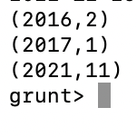

**Insight:**

-The number of accidents in these cities due to fog that makes visibility less than 0.5 mi in 2016 is 2 accidents, while in 2017 it is only one accident, and the highest number of accidents is in 2021, where 11 accidents were recorded this year due to fog.

Separate regions of the north and east of the Kingdom, and the foggy atmosphere included all of the southern region and the mountainous highlands in Asir and Taif, and parts of Hail from Arar and Sakaka, where thick fog formed. It may sometimes be a source of danger for road users due to the lack of horizontal visibility that may reach less than two meters and result in traffic accidents. The dark, foggy atmosphere paralyzes traffic, which sometimes forces motorists to stop and not drive in bad weather for safety reasons.

1. **Find the total number of accidents where the weather condition is cloudy and the state: TX, PX, and FL sort the result by year**

**Result:**

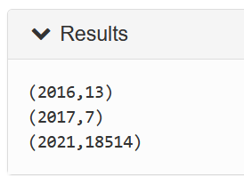

1. **What is the Maximum and Minimum visibility value for accidents that occurred at ‘night’ .Group the result by year.**

**Result:**

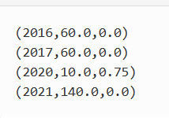

**Insight:**

The result shows the maximum and minimum visibility values for each year. For those accidents that happened at night, we can notice that the maximum visibility value of 140 was recorded in 2021. In the other hand, the minimum visibility values were 0 for most of the years.

1. **What is the Maximum and Minimum visibility value for accidents that occurred on ‘day’? Group the result by year.**

**Result:**

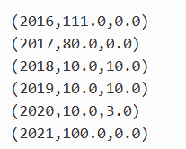

**Insight:**

The result shows the maximum and minimum visibility values for each year. For those accidents that happened during the day, we can notice that the maximum visibility value of 110 was recorded in 2016. And the minimum visibility values were zero for most of the years.

1. **What is the Average wind speed where the severity is 2 and Junction is True? Group by month.**

**Result:**

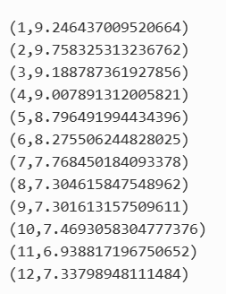

**Insight:**

We can notice that the wind speed was highest from January to April compared to other months of the year. Then the wind speed decreases slightly for the rest of the months.

1. **What is the Average precipitation for the occurred accidents grouped by month?**

**Result:**

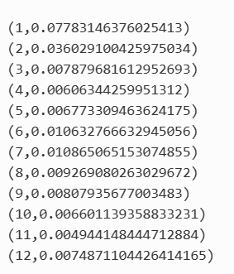

**Insight:**

The average precipitation values were the highest in both January and July compared with other months of the year presented in the dataset.

Rainfall continued in a number of regions of the Kingdom, ranging between medium and heavy, causing the pooling of water, cars, and broken signals, in addition to the presence of obstacles on the road such as trees, stones, and others. As a result, the traffic statistics showed a high incidence of traffic accidents and reports of injuries during rainy days.

1. **How many accidents occurred where there was a roundabout**

**Result:**

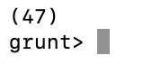

**Insight:**

The number of roundabouts in the US is 5000 roundabouts and the number of accidents when there is a roundabout is 47 accidents which means it's rare to have an accident at a roundabout in the US. However, in Saudi, there are a lot of roundabouts, and one of the top causes of accidents since that Saudi drivers fail to yield at the roundabout.

1. **Number of accidents where the Stop sign is True**

**Result:**

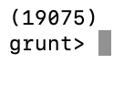

**Insight:**-The number of accidents due to failure to stop at a stop sign is 19075 accidents.

1. **Find the total number of accident where the state is Texas or Florida or Alabama and the visibility is 6 sort the result by the weather condition**

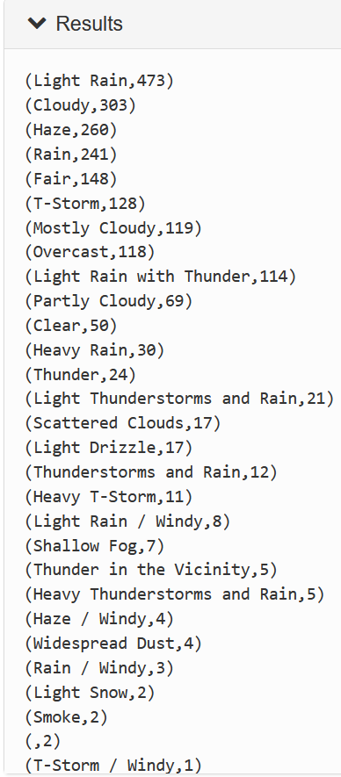

**Insight:**We filtered the visibility to 6 miles, which is the average in Saudi Arabia, and the result shows us the total number of accidents in different weather conditions. We can see that light rain, cloudy weather, and haze are the weather conditions with the highest number of accidents, which makes sense.